**AIDM7360 Group Project**

Group Name: ES (22413731-Lu Tianqing/22443126-Zheng JiaLe/22443118-Li Wenling/22444092-Long Yusen)   
Topic: Indonesia Climate Automated Content Management System

1. **Project description**

Every day, climate data from every climate station around Indonesia was sent to the overall database. How the database organizes tons of data and outputs a report when users like researchers import specific information is a crucial issue. Therefore, this project aims to build a database that stores, organizes, analyses, and outputs a textual and graphic report to users using the query, aggregation, plot and template functions.

1. **Analysis process**
2. **Database**

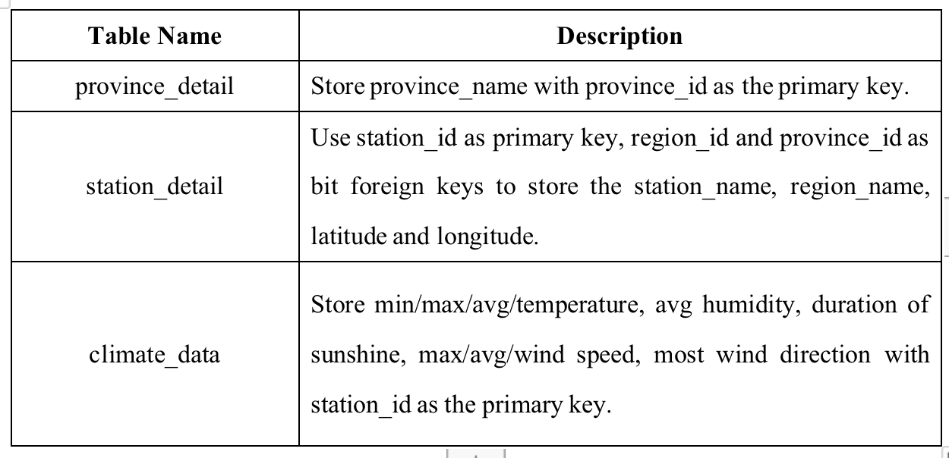

Fig.1 relational database design of the system

1. **Access to the main menu**

The reports are divided into four sections. At the beginning, the user will first go to the main menu and select either the station report, the annual/monthly temperature report, the annual/monthly rainfall report or the annual/monthly wind report.

表格

Fig.2 main menu

1. **Templates of station report**

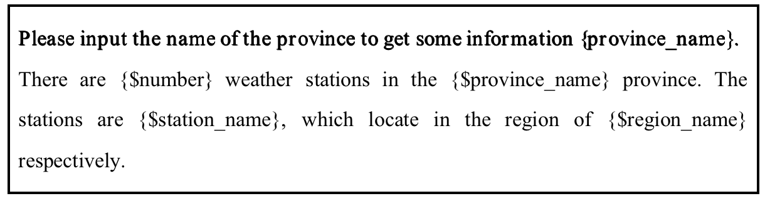Fig.3 station template 1

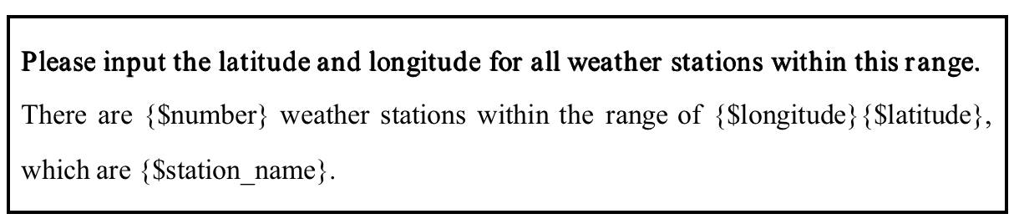Fig.4 station template 2

This is an example of the station report. When the user imports 1, he/she enter the station report templates.

Once in the station screen, when the user enters 1 and then the name of the province they want to know about, it will then output how many weather stations there will be in that province and their respective names.

When the user enters 2, the latitude and longitude are entered once more and the names of the weather stations within this latitude and longitude range are then output

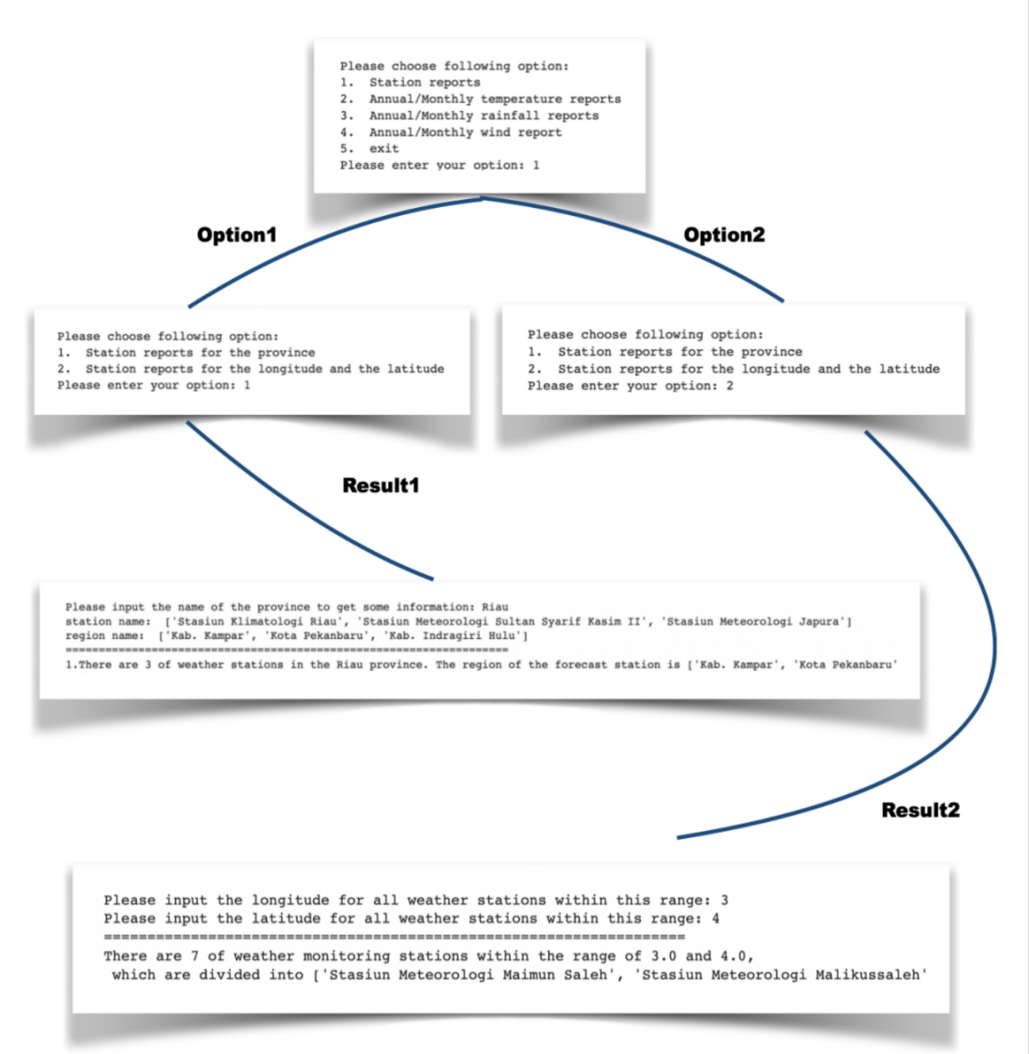

Fig.5 demo process

1. **Templates of temperature report**

Fig.6 monthly temperature template 1

**Please input the year, month and station name for the monthly temperature report:**

In {}/{}, the average temperature this month was {} degrees and the highest average temperature was {} degrees and the lowest average temperature was {} degrees. On {}, the weather station temperature rose to a maximum of {} degrees this month, while on the contrary, the lowest temperature on {} was {} degrees at the weather station. There were {} days with a maximum temperature of 32 degrees or above and {} days with a minimum temperature of 20 degrees or below.

**Please input the year and station name for the annual temperature report:**

In {}, the average temperature this year was {} degrees and the highest average temperature was {} degrees and the lowest average temperature was {} degrees. On {}, the weather station temperature rose to a maximum of {} degrees this year, while on the contrary, the lowest temperature on {} was {} degrees at the weather station. There were {} days with a maximum temperature of 32 degrees or above and {} days with a minimum temperature of 20 degrees or below.

Fig.7 Annual temperature template 1

When users choose option 2 from the main menu, It will go to the interface of checking temperature.

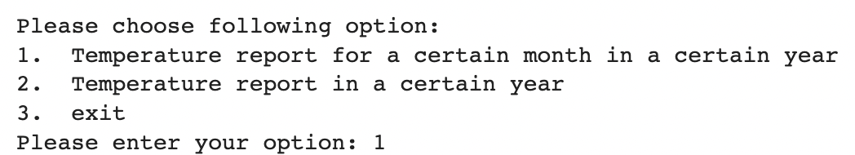Fig.8 Temperature start menu

There are two options in this temperature menu. The first is to check the temperature in a certain month of a certain station. The second is to check the annual report.

For the first option, users will be asked to input the year,month and station name to check the monthly temperature report. Next, the system will show the highest average, lowest average temperature in this month. Besides, the absolute maximum and minimum temperature and the corresponding date will be reported. Furthermore, the number of days higher than 32 degrees and lower than 20 degrees will be counted. Lastly, a line chart of minimum, maximum and average temperature everyday will be generated.

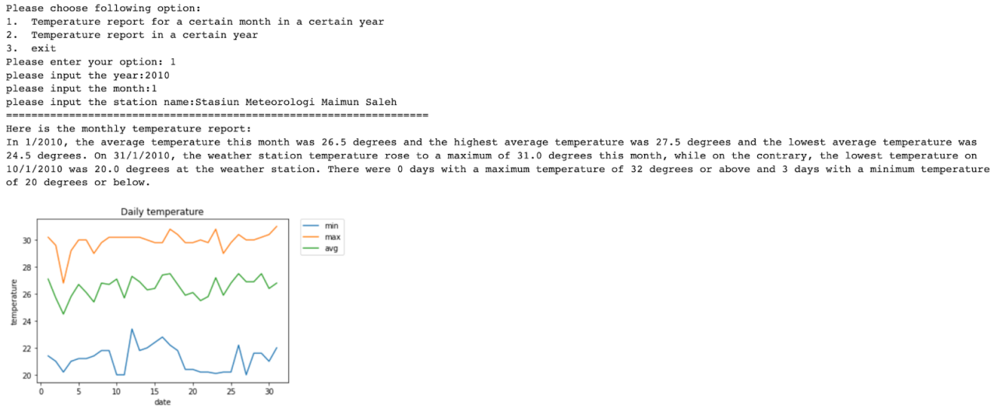

Fig.9 Temperature monthly report example

For the second option, users will be asked to input the year and station name to check the annual temperature report. Similarly, the highest average and lowest average temperature will be shown. The date of the absolute highest and lowest temperature will be displayed. In addition, the total number of days higher than 32 degrees or lower than 20 degrees of the year will be counted. Finally, grouped by month, the line chart shows the changes of maximum, minimum and average temperature of the year.

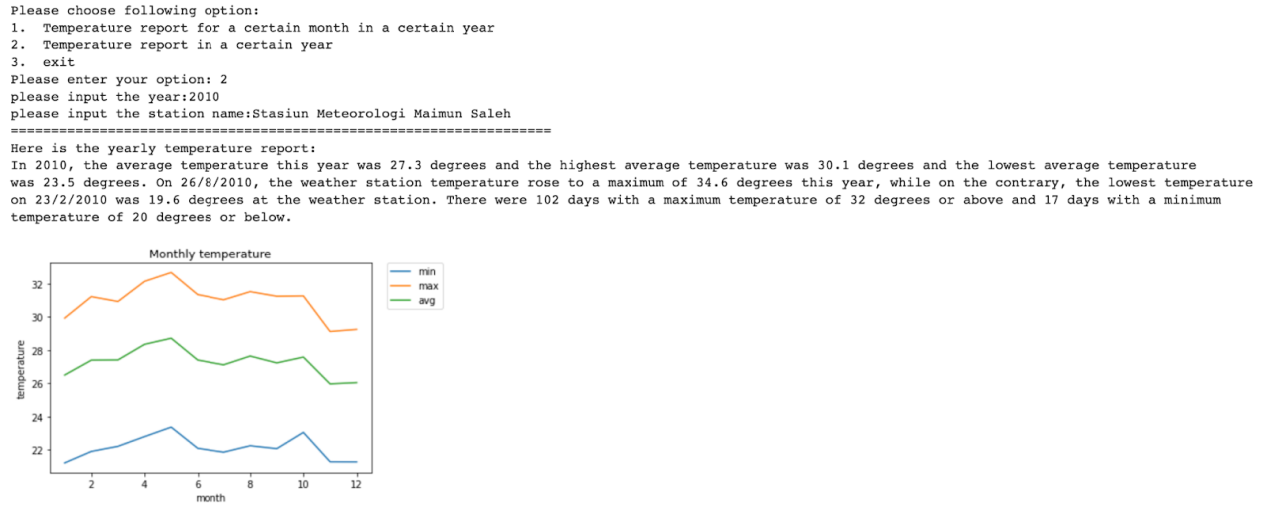Fig.10 Temperature annual report example

1. **Templates of rainfall report**

Fig.11 monthly rainfall template 1

Fig.12 annual rainfall template 2

This is an example of the rainfall report. When user input”3”,the rainfall report screen is accessed.

Fig.13 Rainfall start page

For monthly report, user can input the year, month, station name to query the total rainfall, average rainfall, average humidity, and total sunshine hours during the months. The user can also query which day of the month has the highest rainfall, the highest average humidity, and the longest sunshine hours.

Fig.14 Rainfall monthly report example

For annual report, user can input the year, station name to query the total rainfall, average rainfall, average humidity, and total sunshine hours during this year. The user can also query which month of the year has the highest rainfall, the highest average humidity, and the longest sunshine hours.

图表

Fig.15 Rainfall annual report example

1. **Templates of wind report**

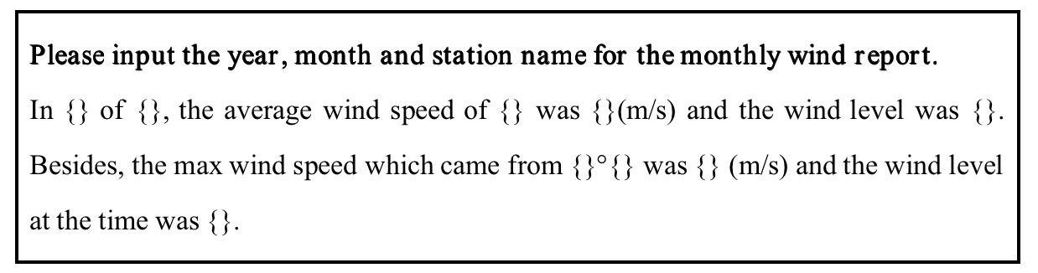

Fig.16 Monthly wind template 1

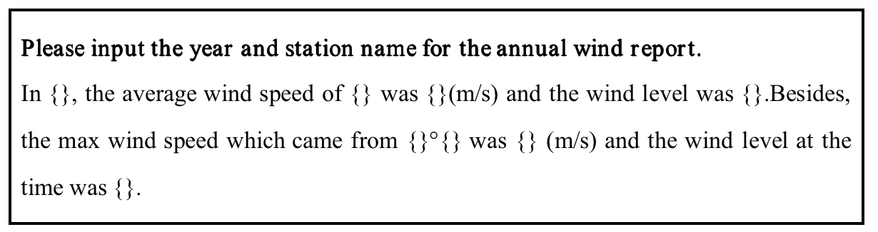

Fig.17 Annual wind template 2

This is an example of the wind report. When the user imports 4, he/she enter the wind report templates.

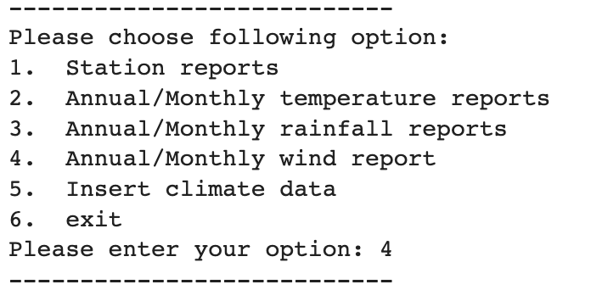

Fig.18 Wind start page

If the user chooses the first option, he/she will access the monthly wind report. After appointing a specific year, month and station name, the user will get a monthly wind report that he/she wants. In this part, users can obtain information about daily average wind speed and wind level in some month.

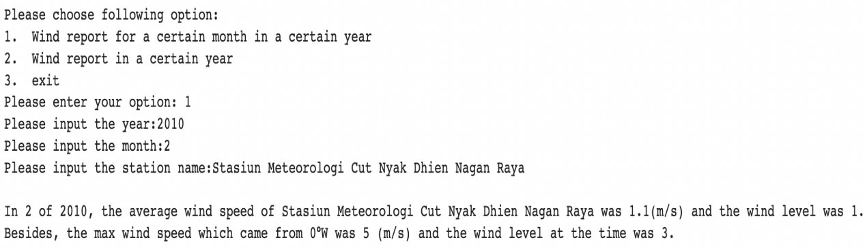Fig.19-1 Wind monthly report example

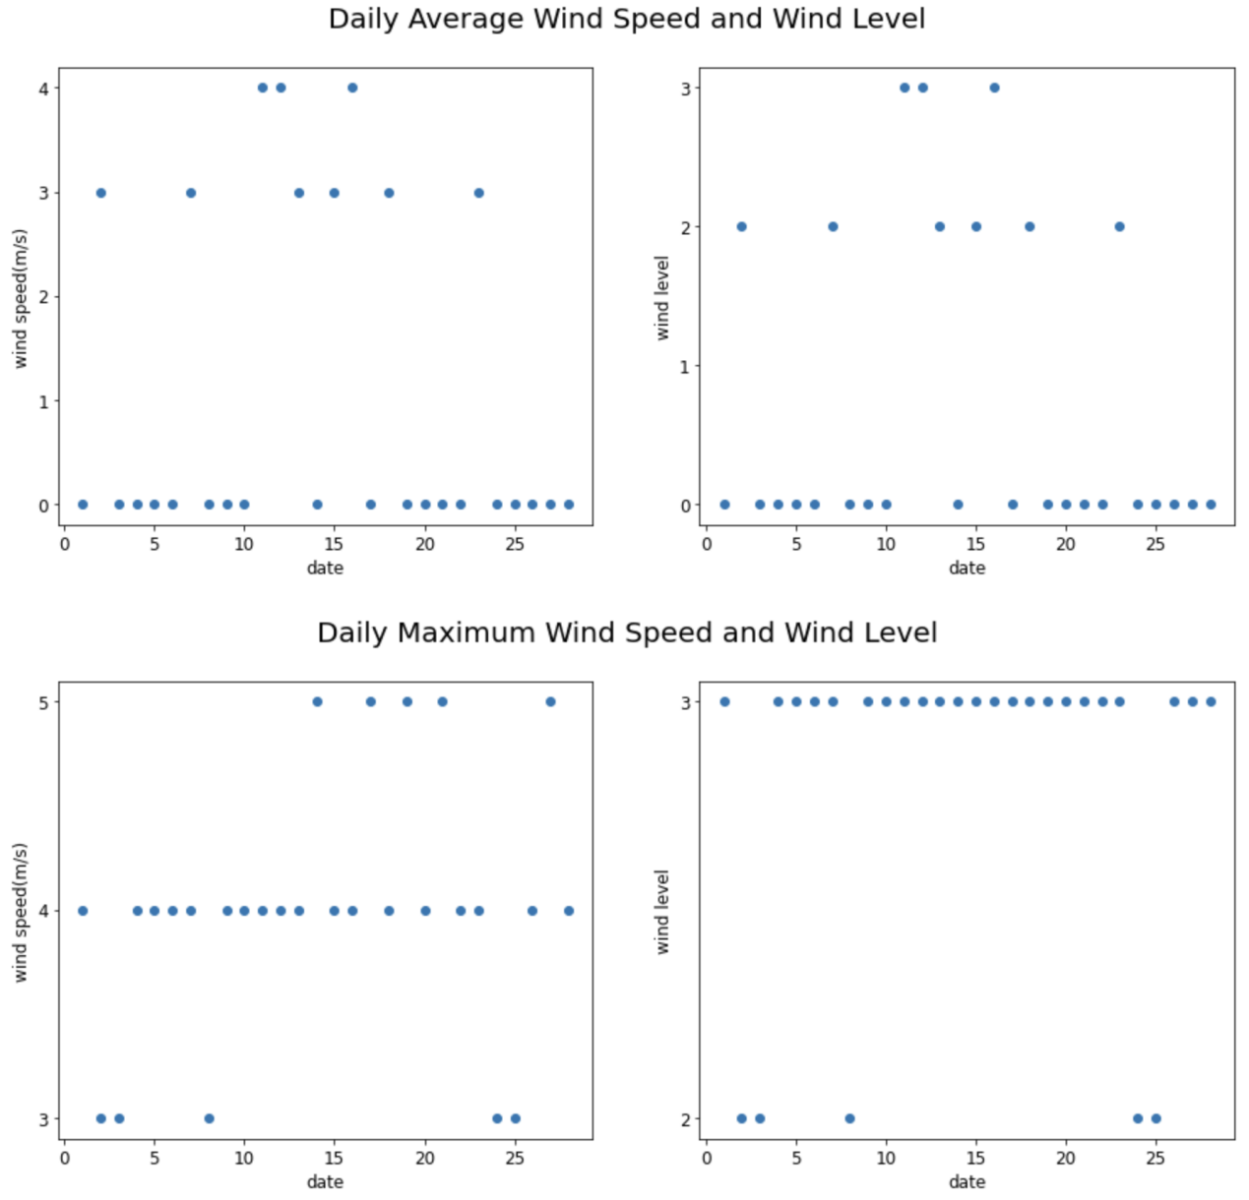

Fig.19-2 Wind monthly report example

If the user chooses the second option, he/she will access the annual wind report. After appointing a specific year and station name, the user will get a annual wind report that he/she wants. In this part, users can obtain information about monthly average wind speed and wind level in some year.

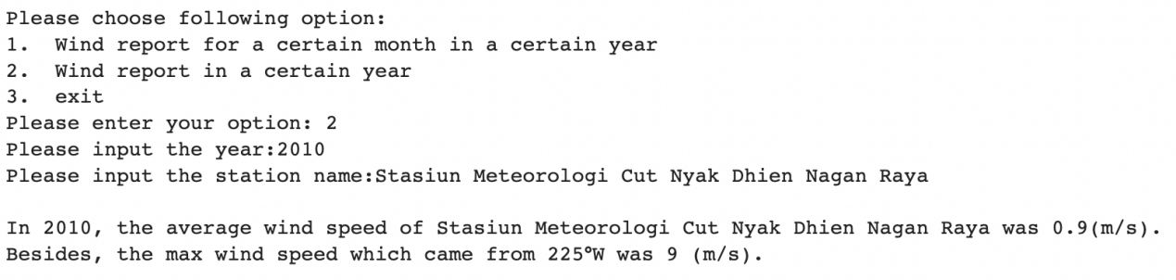

Fig.20-1 Wind annual report example

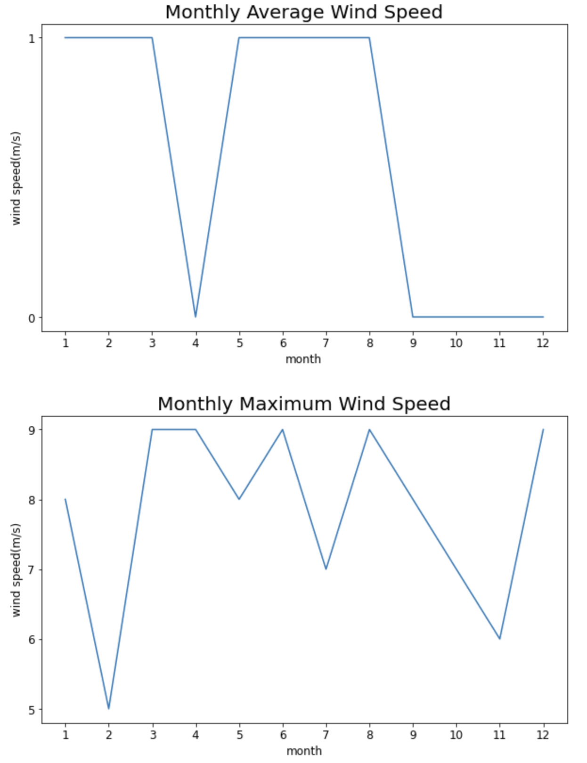

Fig.20-2 Wind annual report example